Міністерство освіти і науки України

Державний університет “Житомирська політехніка”

Кафедра інженерії програмного забезпечення

Група: ВТ-21-1[1]

Програмування мовою Python

Лабораторна робота № 2

«Розгалуження та цикли»

Виконав: Бабушко А. С.

Прийняв: Морозов Д. С.

***Мета роботи:*** познайомитися із структурою розгалуження (if, ifelse, if-elif-else). Ознайомитися з циклічними конструкціями і їх використанням в мові Python. Навчитися працювати з числами і рядками використовуючи дані структури.

***Хід роботи:***

***Завдання на лабораторну роботу:***



***Лістинг програми:***

*""" Lab 2. Python. Andrii Babushko. Repository: https://github.com/AndriiBabushko/Python """  
import* math  
  
  
*# task 1  
def* task_1_interval_int_list(some_int_list):  
 some_result_list = []  
 *for* index *in* range(len(some_int_list)):  
 *if* 1 <= some_int_list[index] <= 3:  
 some_result_list.append(some_int_list[index])  
  
 *return* some_result_list  
  
  
print('\nTASK 1!!!')  
task_1_list = [1, 2, 5, 4, 10, 15, 3]  
print(f'Task 1 list: {task_1_list}')  
print(f'List of elems that in interval [1; 3]: {task_1_interval_int_list(task_1_list)}')

***Результат програми:***

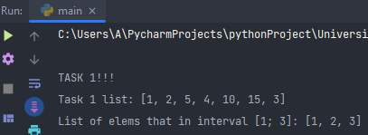

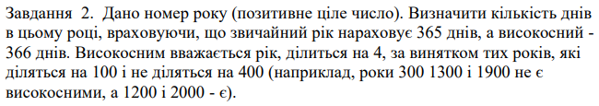

***Лістинг програми:***

*# task 2  
def* task_2_year_days(year):  
 *if* is_leap_year(year):  
 print(f'This year({year}) has 366 days.')  
 *else*:  
 print(f'This year({year}) has 365 days.')  
  
  
*def* is_leap_year(year):  
 *if* year % 400 == 0 *or* (year % 4 == 0 *and* year % 100 != 0):  
 *return True  
 return False*print('\nTASK 2!!!')  
task_2_year = [2000, 2001, 1932, 1841, 2004, 2014]  
*for* i *in* range(len(task_2_year)):  
 task_2_year_days(task_2_year[i])

***Результат програми:***

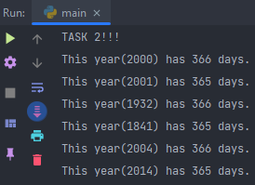

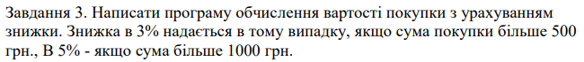

***Лістинг програми:***

*# task 3  
def* task_3_purchase_discount(purchase):  
 *if* 500 <= purchase < 1000:  
 *return* purchase - purchase * 0.03  
 *if* purchase >= 1000:  
 *return* purchase - purchase * 0.05  
 *return* purchase  
  
  
print('\nTASK 3!!!')  
task_3_purchases = [490, 510, 800, 1100, 2100]  
*for* i *in* range(len(task_3_purchases)):  
 print(f'Purchase: {task_3_purchases[i]}\nFinal price: {task_3_purchase_discount(task_3_purchases[i])}\n')

***Результат програми:***

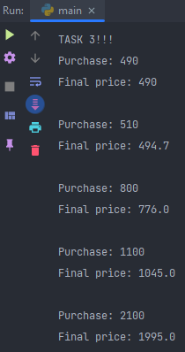



***Лістинг програми:***

*# task 4  
def* task_4_min_cosine(angles):  
 *return* math.cos(min(angles))  
  
  
print('\nTASK 4!!!')  
angles_list = [math.radians(30 / math.pi), math.radians(60 / math.pi), math.radians(90 / math.pi),  
 math.radians(120 / math.pi), math.radians(360 / math.pi)]  
print(f'Angles list: {angles_list}')  
print(f'Min cos in radians from angles list: {task_4_min_cosine(angles_list)}')

***Результат програми:***

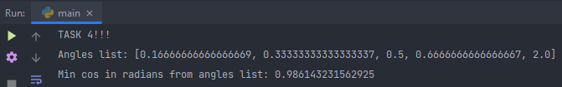



***Лістинг програми:***

*# task 5  
def* task_5_max_sin(angles):  
 *return* math.sin(max(angles))  
  
  
print('\nTASK 5!!!')  
print(f'Angles list: {angles_list}')  
print(f'Max sin in radians from angles list: {task_5_max_sin(angles_list)}')

***Результат програми:***

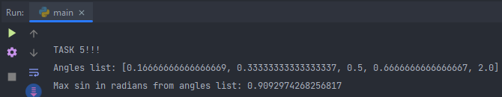

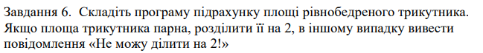

***Лістинг програми:***

*# task 6  
def* task_6_isosceles_triangle(sides):  
 s = (sides[0] * sides[1]) / 2  
 *if* s % 2 == 0:  
 s /= 2  
 print(f'The area of the triangle: {s}')  
 *else*:  
 print(f"The S({s}), I can\'t divide by 2!")  
  
  
print('\nTASK 6!!!')  
left_right_sides = 1  
base_side = 2  
*for* x *in* range(1, 13, 3):  
 task_6_isosceles_triangle([left_right_sides + x, base_side + x])

***Результат програми:***

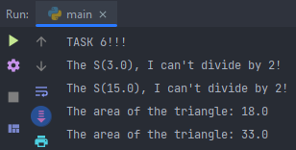



***Лістинг програми:***

*# task 7  
def* task_7_english_month(month_number):  
 months = ['January', 'February', 'March', 'April', 'May', 'June', 'July', 'August', 'September', 'October',  
 'November', 'December']  
 *if* 1 <= month_number <= 12:  
 print(f'{month_number} month is {months[month_number - 1]}')  
 *else*:  
 print(f'{month_number} number of month isn\'t in range [1, 12]!')  
  
  
print('\nTASK 7!!!')  
*for* i *in* range(0, 14):  
 task_7_english_month(i)

***Результат програми:***

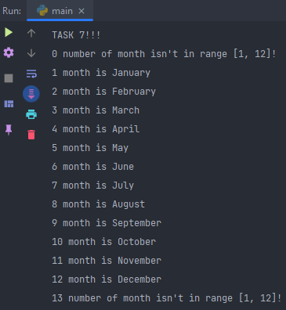



***Лістинг програми:***

*# task 8  
def* task_8_positive_numbers(numbers):  
 positive_counter = 0  
 *for* number *in* numbers:  
 *if* number >= 1:  
 positive_counter += 1  
 *return* positive_counter  
  
  
print('\nTASK 8!!!')  
some_numbers = [10, -10, -10.5, -143411, 12032, +120, 1, 0, -1]  
print(f'Range of numbers: {some_numbers}')  
print(f'Number of positive numbers in range: {task_8_positive_numbers(some_numbers)}')

***Результат програми:***

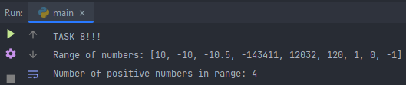



***Лістинг програми:***

*# task 9  
def* task_9_sum_some_range(a, b):  
 sum_some_range = 0  
 *for* some_num *in* range(a, b + 1, 1):  
 sum_some_range += some_num  
  
 *return* sum_some_range  
  
  
print('\nTASK 9!!!')  
A = 5  
B = 15  
print(f'Sum of range from A({A}) to B({B}): {task_9_sum_some_range(A, B)}')

***Результат програми:***

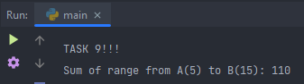

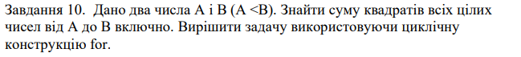

***Лістинг програми:***

*# task 10  
def* task_10_sum_squares_some_range(a, b):  
 sum_squares_some_range = 0  
 *for* some_num *in* range(a, b + 1, 1):  
 sum_squares_some_range += math.pow(some_num, 2)  
  
 *return* sum_squares_some_range  
  
  
print('\nTASK 10!!!')  
print(f'Sum of squares of range from A({A}) to B({B}): {task_10_sum_squares_some_range(A, B)}')

***Результат програми:***

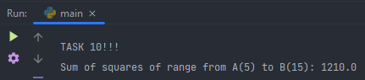

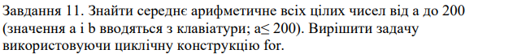

***Лістинг програми:***

*# task 11  
def* task_11_arithmetic_mean(a, b):  
 arithmetic_mean_sum = 0  
 count_nums = 0  
 *for* some_num *in* range(a, b + 1):  
 arithmetic_mean_sum += some_num  
 count_nums += 1  
  
 *return* arithmetic_mean_sum / count_nums  
  
  
*def* enter_A_and_B():  
 *while True*:  
 a = int(input('Enter A for task 11: '))  
 b = int(input('Enter B for task 11: '))  
 *if* a < b:  
 *break  
  
 return* [a, b]  
  
  
print('\nTASK 11!!!')  
some_range = enter_A_and_B()  
print(f'Arithmetic mean from A({some_range[0]}) to B({some_range[1]}):'  
 f'{task_11_arithmetic_mean(some_range[0], some_range[1])}')

***Результат програми:***

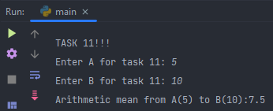

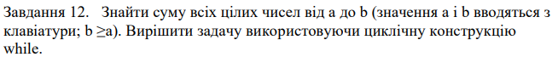

***Лістинг програми:***

*# task 12  
def* task_12_sum_some_range(a, b):  
 sum_some_range = 0  
 *while* a <= b:  
 sum_some_range += a  
 a += 1  
  
 *return* sum_some_range  
  
  
print('\nTASK 12!!!')  
print(f'Sum of range from A({A}) to B({B}): {task_12_sum_some_range(A, B)}')

***Результат програми:***

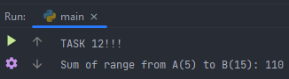

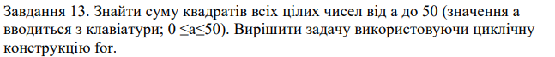

***Лістинг програми:***

*# task 13  
def* task_13_sum_some_square_range(a):  
 sum_some_squares = 0  
 *for* sum_num *in* range(a, 51, 1):  
 sum_some_squares += math.pow(sum_num, 2)  
  
 *return* sum_some_squares  
  
  
print('\nTASK 13!!!')  
A = 48  
print(f'Sum of squares of range from A({A}) to 50: {task_13_sum_some_square_range(A)}')

***Результат програми:***

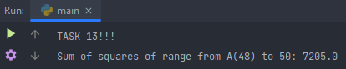

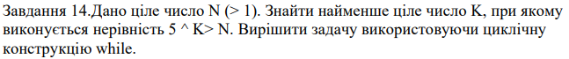

***Лістинг програми:***

*# task 14  
def* task_14_find_K(N_number):  
 K = N_number  
 K_array = [K]  
 *while* math.pow(5, K) > N_number:  
 K -= 1  
 K_array.append(K)  
  
 *return* min(K_array)  
  
  
*def* enter_N():  
 *while True*:  
 some_N = int(input('Enter N: '))  
 *if* some_N > 1:  
 *break  
  
 return* some_N  
  
  
print('\nTASK 14!!!')  
N = enter_N()  
print(f'Some K from N({N}): {task_14_find_K(N)}')

***Результат програми:***

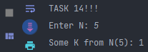



***Лістинг програми:***

*# task 15  
def* task_15_find_number_greater_n(n):  
 *for* number *in* range(1, n, 1):  
 some_number = math.pow(number, 2)  
 *if* some_number > n:  
 *return* some_number  
 *else*:  
 *continue  
  
 return* n  
  
  
print('\nTASK 15!!!')  
N = enter_N()  
print(f'The first number that greater than n: {task_15_find_number_greater_n(N)}')

***Результат програми:***

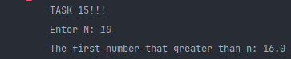

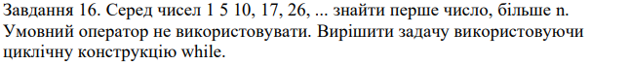

***Лістинг програми:***

*# task 16  
def* task_16_find_number_greater_n(n):  
 some_number = 1  
 iterator = 2  
 *while* some_number < n:  
 some_number = math.pow(iterator, 2) + 1  
 iterator += 1  
  
 *return* some_number  
  
  
print('\nTASK 16!!!')  
N = enter_N()  
print(f'The first number that greater than n: {task_16_find_number_greater_n(N)}')

***Результат програми:***

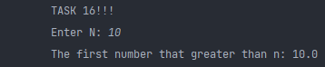

***Увесь лістинг програми:***

*""" Lab 2. Python. Andrii Babushko. Repository: https://github.com/AndriiBabushko/Python """  
import* math  
  
  
*# task 1  
def* task_1_interval_int_list(some_int_list):  
 some_result_list = []  
 *for* index *in* range(len(some_int_list)):  
 *if* 1 <= some_int_list[index] <= 3:  
 some_result_list.append(some_int_list[index])  
  
 *return* some_result_list  
  
  
print('\nTASK 1!!!')  
task_1_list = [1, 2, 5, 4, 10, 15, 3]  
print(f'Task 1 list: {task_1_list}')  
print(f'List of elems that in interval [1; 3]: {task_1_interval_int_list(task_1_list)}')  
  
  
*# task 2  
def* task_2_year_days(year):  
 *if* is_leap_year(year):  
 print(f'This year({year}) has 366 days.')  
 *else*:  
 print(f'This year({year}) has 365 days.')  
  
  
*def* is_leap_year(year):  
 *if* year % 400 == 0 *or* (year % 4 == 0 *and* year % 100 != 0):  
 *return True  
 return False*print('\nTASK 2!!!')  
task_2_year = [2000, 2001, 1932, 1841, 2004, 2014]  
*for* i *in* range(len(task_2_year)):  
 task_2_year_days(task_2_year[i])  
  
  
*# task 3  
def* task_3_purchase_discount(purchase):  
 *if* 500 <= purchase < 1000:  
 *return* purchase - purchase * 0.03  
 *if* purchase >= 1000:  
 *return* purchase - purchase * 0.05  
 *return* purchase  
  
  
print('\nTASK 3!!!')  
task_3_purchases = [490, 510, 800, 1100, 2100]  
*for* i *in* range(len(task_3_purchases)):  
 print(f'Purchase: {task_3_purchases[i]}\nFinal price: {task_3_purchase_discount(task_3_purchases[i])}\n')  
  
  
*# task 4  
def* task_4_min_cosine(angles): *return* math.cos(min(angles))  
  
  
print('\nTASK 4!!!')  
angles_list = [math.radians(30 / math.pi), math.radians(60 / math.pi), math.radians(90 / math.pi),  
 math.radians(120 / math.pi), math.radians(360 / math.pi)]  
print(f'Angles list: {angles_list}')  
print(f'Min cos in radians from angles list: {task_4_min_cosine(angles_list)}')  
  
  
*# task 5  
def* task_5_max_sin(angles): *return* math.sin(max(angles))  
  
  
print('\nTASK 5!!!')  
print(f'Angles list: {angles_list}')  
print(f'Max sin in radians from angles list: {task_5_max_sin(angles_list)}')  
  
  
*# task 6  
def* task_6_isosceles_triangle(sides):  
 s = (sides[0] * sides[1]) / 2  
 *if* s % 2 == 0:  
 s /= 2  
 print(f'The area of the triangle: {s}')  
 *else*:  
 print(f"The S({s}), I can\'t divide by 2!")  
  
  
print('\nTASK 6!!!')  
left_right_sides = 1  
base_side = 2  
*for* x *in* range(1, 13, 3):  
 task_6_isosceles_triangle([left_right_sides + x, base_side + x])  
  
  
*# task 7  
def* task_7_english_month(month_number):  
 months = ['January', 'February', 'March', 'April', 'May', 'June', 'July', 'August', 'September', 'October',  
 'November', 'December']  
 *if* 1 <= month_number <= 12:  
 print(f'{month_number} month is {months[month_number - 1]}')  
 *else*:  
 print(f'{month_number} number of month isn\'t in range [1, 12]!')  
  
  
print('\nTASK 7!!!')  
*for* i *in* range(0, 14):  
 task_7_english_month(i)  
  
  
*# task 8  
def* task_8_positive_numbers(numbers):  
 positive_counter = 0  
 *for* number *in* numbers:  
 *if* number >= 1:  
 positive_counter += 1  
 *return* positive_counter  
  
  
print('\nTASK 8!!!')  
some_numbers = [10, -10, -10.5, -143411, 12032, +120, 1, 0, -1]  
print(f'Range of numbers: {some_numbers}')  
print(f'Number of positive numbers in range: {task_8_positive_numbers(some_numbers)}')  
  
  
*# task 9  
def* task_9_sum_some_range(a, b):  
 sum_some_range = 0  
 *for* some_num *in* range(a, b + 1, 1):  
 sum_some_range += some_num  
  
 *return* sum_some_range  
  
  
print('\nTASK 9!!!')  
A = 5  
B = 15  
print(f'Sum of range from A({A}) to B({B}): {task_9_sum_some_range(A, B)}')  
  
  
*# task 10  
def* task_10_sum_squares_some_range(a, b):  
 sum_squares_some_range = 0  
 *for* some_num *in* range(a, b + 1, 1):  
 sum_squares_some_range += math.pow(some_num, 2)  
  
 *return* sum_squares_some_range  
  
  
print('\nTASK 10!!!')  
print(f'Sum of squares of range from A({A}) to B({B}): {task_10_sum_squares_some_range(A, B)}')  
  
  
*# task 11  
def* task_11_arithmetic_mean(a, b):  
 arithmetic_mean_sum = 0  
 count_nums = 0  
 *for* some_num *in* range(a, b + 1):  
 arithmetic_mean_sum += some_num  
 count_nums += 1  
  
 *return* arithmetic_mean_sum / count_nums  
  
  
*def* enter_A_and_B():  
 *while True*:  
 a = int(input('Enter A for task 11: '))  
 b = int(input('Enter B for task 11: '))  
 *if* a < b:  
 *break  
  
 return* [a, b]  
  
  
print('\nTASK 11!!!')  
some_range = enter_A_and_B()  
print(f'Arithmetic mean from A({some_range[0]}) to B({some_range[1]}):'  
 f'{task_11_arithmetic_mean(some_range[0], some_range[1])}')  
  
  
*# task 12  
def* task_12_sum_some_range(a, b):  
 sum_some_range = 0  
 *while* a <= b:  
 sum_some_range += a  
 a += 1  
  
 *return* sum_some_range  
  
  
print('\nTASK 12!!!')  
print(f'Sum of range from A({A}) to B({B}): {task_12_sum_some_range(A, B)}')  
  
  
*# task 13  
def* task_13_sum_some_square_range(a):  
 sum_some_squares = 0  
 *for* sum_num *in* range(a, 51, 1):  
 sum_some_squares += math.pow(sum_num, 2)  
  
 *return* sum_some_squares  
  
  
print('\nTASK 13!!!')  
A = 48  
print(f'Sum of squares of range from A({A}) to 50: {task_13_sum_some_square_range(A)}')  
  
  
*# task 14  
def* task_14_find_K(N_number):  
 K = N_number  
 K_array = [K]  
 *while* math.pow(5, K) > N_number:  
 K -= 1  
 K_array.append(K)  
  
 *return* min(K_array)  
  
  
*def* enter_N():  
 *while True*:  
 some_N = int(input('Enter N: '))  
 *if* some_N > 1:  
 *break  
  
 return* some_N  
  
  
print('\nTASK 14!!!')  
N = enter_N()  
print(f'Some K from N({N}): {task_14_find_K(N)}')  
  
  
*# task 15  
def* task_15_find_number_greater_n(n):  
 *for* number *in* range(1, n, 1):  
 some_number = math.pow(number, 2)  
 *if* some_number > n:  
 *return* some_number  
 *else*:  
 *continue  
  
 return* n  
  
  
print('\nTASK 15!!!')  
N = enter_N()  
print(f'The first number that greater than n: {task_15_find_number_greater_n(N)}')  
  
  
*# task 15  
def* task_16_find_number_greater_n(n):  
 some_number = 1  
 iterator = 2  
 *while* some_number < n:  
 some_number = math.pow(iterator, 2) + 1  
 iterator += 1  
  
 *return* some_number  
  
  
print('\nTASK 16!!!')  
N = enter_N()  
print(f'The first number that greater than n: {task_16_find_number_greater_n(N)}')

***Висновок:*** під час виконання лабораторної роботи було отримано навички з написання простих скриптів з використанням циклів for та while, перевірок умови if на мові Python.